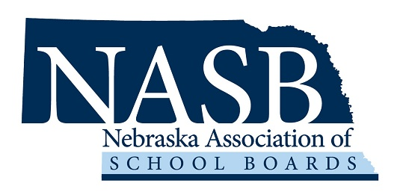
Education Leadership Search Service
Sterling Public Schools
District Engagement Survey

As the Sterling Board of Education embarks upon the process to hire a new superintendent, the board is seeking the input of staff and community members. The NASB Education Leadership Search Service provides various methods for sharing your “confidential” comments. You may submit your personal comments via one of the following:

- Access the online form at Survey Monkey
Link: https://www.surveymonkey.com/r/SterlingJets

- Email: sbecker@nasbonline.org

- A copy of this form is available at the Superintendent’s Office.

Superintendent Search District Engagement Survey

1. What are the strengths and accomplishments of the school district?

2. What are the strengths or advantages of the community?

3. What challenges are the district currently facing or will the district face in the coming years?

4. What background experience should the new superintendent possess?

5. What personal and professional qualities will be important in a new superintendent?

